**Assignment-1**

**Problem statement**

* Project Name

Web-application for Spam Classification for Desktop

* Describing how things should work

---Software Specifications---

* Python 3.8
* HTML 5
* CSS 3
* Flask 1.1
* Operating System – Independent
* Problem and Why it matters

In recent days our PC’s have became a hub for notifications from all over the web as well as system including the Emails, Whatsapp messages, Browser notifications, System Notifications. Notification spam is one of the major problems of the today’s Internet, bringing financial damage to companies and annoying individual users. Among the approaches developed to stop spam, filtering is the one of the most important technique.

So it has became a challenge for us to distinguish between the two classes of notification, i.e., SPAM or HAM.

* Problem’s financial cost

---NONE---

* Solution

The solution for this problem is to use Machine Learning and Natural Language Processing for teaching the system how to deal with different types of notification from different sources and whether to show it to the user or not on the basis of model classification in two classes, i.e., SPAM or HAM.

Here we are using Naïve Bayes Algorithm for classifying each type of messages in two classes.

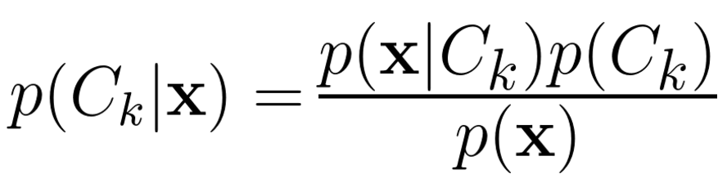

* Benefits of Proposed solution
* Used for all types of Notifications
* Reduced Wastage of time
* System Independent
* User friendly GUI
* Basic Cyber Security
* Offline
* Conclusion

Though we can conclude that this Spam Classification technique can be used on any system to distinguish from System to multiple Application Software notifications. Therefore, it would be easier for the user to just have a look on only those notifications which is either helpful for him or the system which will surely increase his/her productivity